**Paper Title (Times New Roman 14)**

First Authora*, Second Authorb, … Last Authorc

*a Professor, China University of Petroleum (Beijing), Beijing, China*

*bEngineer, Bohai Petroleum Research Institute, Tianjin Branch, CNOOC (China) Co., Ltd., Tianjin, China*

*c Undergraduate Student, China University of Petroleum (Beijing), Beijing, China*

*\*Corresponding Author’s E-mail*: pric2025@cup.edu.cn

**Abstract**

Length of the abstract should be no more than 300 words. Length of the abstract should be no more than 300 words. Length of the abstract should be no more than 300 words. Length of the abstract should be no more than 300 words. Length of the abstract should be no more than 300 words. Length of the abstract should be no more than 300 words.

**Keywords:** Key word 1; key word 2; key word 3; key word 4 (no more than 5)

**1. Introduction**

Times New Roman 11. Single line spacing. References with superscript references [1]. The list of references should be placed at the end of the manuscript in the cited order.

Times New Roman 11. Single line spacing. References with superscript references [2]. Times New Roman 11. Single line spacing. References with superscript references [3]. Times New Roman 11. Single line spacing. References with superscript references [4].

… … …

The equations should be justified at the center and the euqation numbers in parenthesis should be justified on the right side.

 (1)

The tables and figures should be numbered in sequence and captioned. The followings are the examples for a table and a figure.

|  |  |  |  |  |
| --- | --- | --- | --- | --- |
| Drilling  Parameters | Hardness of Rock | | RQD | |
| Soft | Hard | Increase | Decrease |
| Tool pressure (bar) | Constant | Constant | Constant | Constant |
| Instantaneous advance speed (m/h) | Increased | Decreased | Constant | Increased |

Table 1. Drilling performance parameters related to rock mass condition

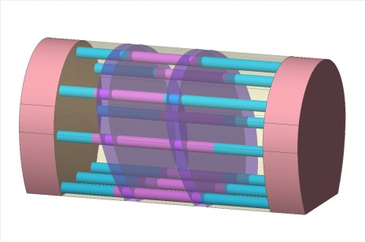

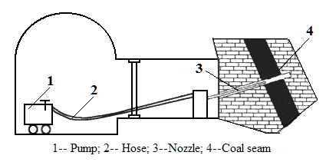

Fig. 1 Sample picture

Please submit your final manuscript no later than August 15, 2025 through E-mail: pric2025@cup.edu.cn.

For any questions with the full paper submission, please contact with the Organizing Committee at pric2025@cup.edu.cn.

**Acknowledgement**

This work was supported by the National Natural Science Foundation of China (Grant No2025001001).

**References**

[1] Hashish, M. Performance of high-pressure abrasive suspension jet system, American Society of Mechanical Engineers. 2002, 67: 199-207.

[2] Shimizu, S.; Hiraoka, Y.; Nishiyama, T. A sheathed nozzle for abrasive water suspension jets in submerged environments. 17th International Conference on Water Jetting: Advances and Future Needs, 2004, 197-204.

[3] Li Xiaohong, Sihu, Xie Yanmin. Numerical simulation of rock fracture under high pressure water jet [J]. Key Engineering Materials, 2011(462-463): 785-790.